**微算機系統**

**小組報告**

**實驗一**

**組別十九**

**110590001 郭丞軒**

**110590002 王熯紘**

**2022/9/20**

* **實驗內容：**
  + **目標一:**

**控制四個開關使一個七段顯示器輸出0~F**

* + **目標二:**

**控制十二個開關使三個七段顯示器輸出000~FFF**

* **實驗過程及結果：**

**先用 switch case 達成目標一，後來發現只能用邏輯電路完成，便重構程式碼，最後成功利用邏輯電路完成目標一、二。**

* **根據以下邏輯化簡設計程式碼：**

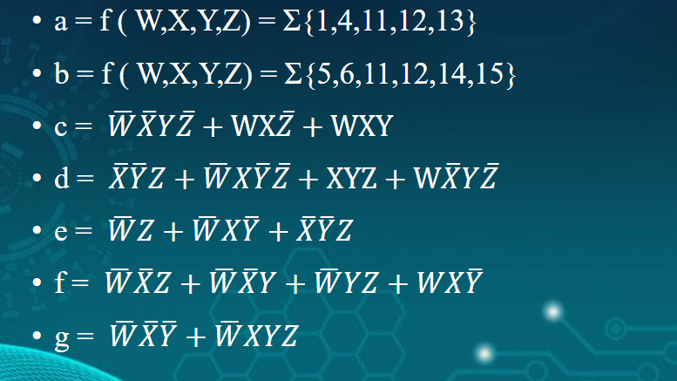

* **電路圖：**

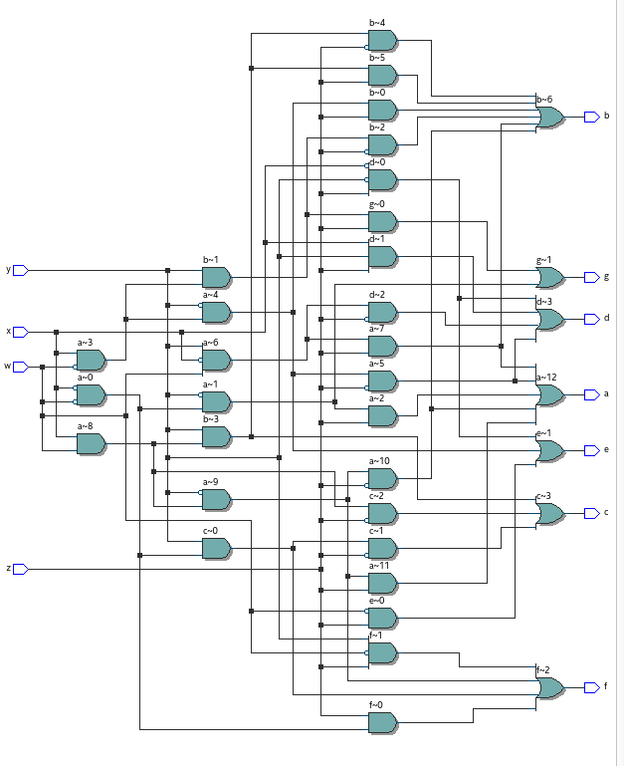

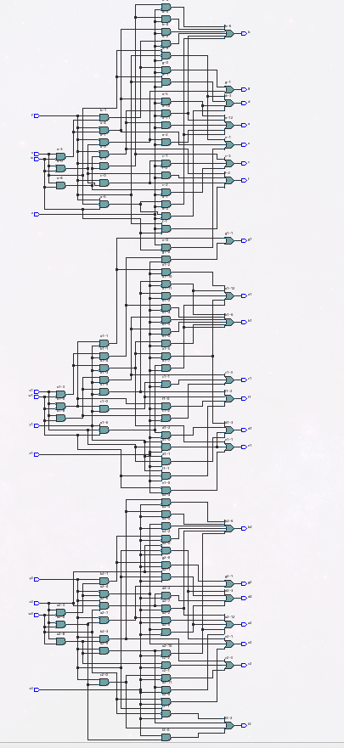

* **實驗結果：**

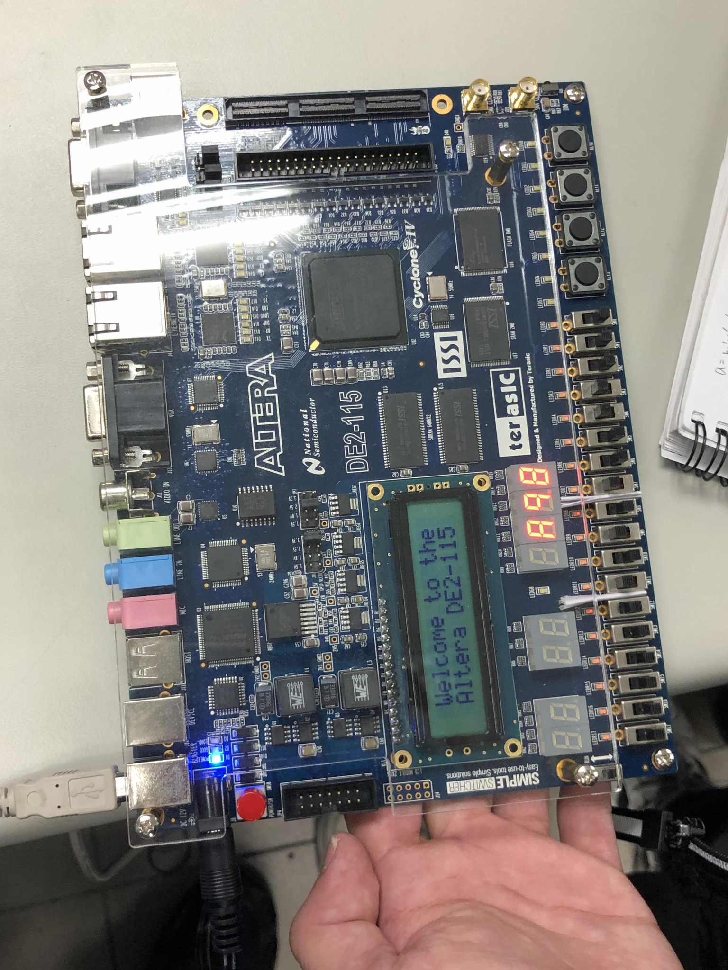

* **程式碼：**
  + **目標一:**

library ieee;

use ieee.std_logic_1164.all;

use ieee.std_logic_unsigned.all;

use ieee.numeric_std.all;

entity part1 is

port (

z, y, x, w: in std_logic;

a, b, c, d, e, f, g: out std_logic

);

end part1;

architecture dosth of part1 is

signal arr: std_logic_vector(6 downto 0);

signal arr1: std_logic_vector(6 downto 0);

signal arr2: std_logic_vector(6 downto 0);

signal input: std_logic_vector(3 downto 0);

signal tmp: integer;

begin

a <= (not w and not x and not y and z) or

(not w and x and not y and not z)or

(w and not x and y and z )or

(w and x and not y and not z )or

(w and x and not y and z);

b <= (not w and x and not y and z)or

(not w and x and y and not z)or

(w and not x and y and z)or

(w and x and not y and not z)or

(w and x and y and not z) or

(w and x and y and z);

c <= (not w and not x and y and not z) or

(w and x and not z) or

(w and x and y);

d <= (not x and not y and z) or

(not w and x and not y and not z) or

(x and y and z) or

(w and not x and y and not z);

e <= (not w and z) or

(not w and x and not y)or

(not x and not y and z);

f <= (not w and not x and z )or

(not w and not x and y)or

(not w and y and z)or

(w and x and not y);

g <= (not w and not x and not y )or

(not w and x and y and z);

end dosth;

* + **目標二:**

library ieee;

use ieee.std_logic_1164.all;

use ieee.std_logic_unsigned.all;

use ieee.numeric_std.all;

entity lab1 is

port (

z, y, x, w: in std_logic;

z1, y1, x1, w1: in std_logic;

z2, y2, x2, w2: in std_logic;

a, b, c, d, e, f, g: out std_logic;

a1, b1, c1, d1, e1, f1, g1: out std_logic;

a2, b2, c2, d2, e2, f2, g2: out std_logic

);

end lab1;

architecture dosth of lab1 is

signal arr: std_logic_vector(6 downto 0);

signal arr1: std_logic_vector(6 downto 0);

signal arr2: std_logic_vector(6 downto 0);

signal input: std_logic_vector(3 downto 0);

signal tmp: integer;

begin

a <= (not w and not x and not y and z) or

(not w and x and not y and not z)or

(w and not x and y and z )or

(w and x and not y and not z )or

(w and x and not y and z);

b <= (not w and x and not y and z)or

(not w and x and y and not z)or

(w and not x and y and z)or

(w and x and not y and not z)or

(w and x and y and not z) or

(w and x and y and z);

c <= (not w and not x and y and not z) or

(w and x and not z) or

(w and x and y);

d <= (not x and not y and z) or

(not w and x and not y and not z) or

(x and y and z) or

(w and not x and y and not z);

e <= (not w and z) or

(not w and x and not y)or

(not x and not y and z);

f <= (not w and not x and z )or

(not w and not x and y)or

(not w and y and z)or

(w and x and not y);

g <= (not w and not x and not y )or

(not w and x and y and z);

a1 <= (not w1 and not x1 and not y1 and z1) or

(not w1 and x1 and not y1 and not z1)or

(w1 and not x1 and y1 and z1 )or

(w1 and x1 and not y1 and not z1 )or

(w1 and x1 and not y1 and z1);

b1 <= (not w1 and x1 and not y1 and z1)or

(not w1 and x1 and y1 and not z1)or

(w1 and not x1 and y1 and z1)or

(w1 and x1 and not y1 and not z1)or

(w1 and x1 and y1 and not z1) or

(w1 and x1 and y1 and z1);

c1 <= (not w1 and not x1 and y1 and not z1) or

(w1 and x1 and not z1) or

(w1 and x1 and y1);

d1 <= (not x1 and not y1 and z1) or

(not w1 and x1 and not y1 and not z1) or

(x1 and y1 and z1) or

(w1 and not x1 and y1 and not z1);

e1 <= (not w1 and z1) or

(not w1 and x1 and not y1)or

(not x1 and not y1 and z1);

f1 <= (not w1 and not x1 and z1 )or

(not w1 and not x1 and y1)or

(not w1 and y1 and z1)or

(w1 and x1 and not y1);

g1 <= (not w1 and not x1 and not y1 )or

(not w1 and x1 and y1 and z1);

a2 <= (not w2 and not x2 and not y2 and z2) or

(not w2 and x2 and not y2 and not z2)or

(w2 and not x2 and y2 and z2 )or

(w2 and x2 and not y2 and not z2 )or

(w2 and x2 and not y2 and z2);

b2 <= (not w2 and x2 and not y2 and z2)or

(not w2 and x2 and y2 and not z2)or

(w2 and not x2 and y2 and z2)or

(w2 and x2 and not y2 and not z2)or

(w2 and x2 and y2 and not z2) or

(w2 and x2 and y2 and z2);

c2 <= (not w2 and not x2 and y2 and not z2) or

(w2 and x2 and not z2) or

(w2 and x2 and y2);

d2 <= (not x2 and not y2 and z2) or

(not w2 and x2 and not y2 and not z2) or

(x2 and y2 and z2) or

(w2 and not x2 and y2 and not z2);

e2 <= (not w2 and z2) or

(not w2 and x2 and not y2)or

(not x2 and not y2 and z2);

f2 <= (not w2 and not x2 and z2 )or

(not w2 and not x2 and y2)or

(not w2 and y2 and z2)or

(w2 and x2 and not y2);

g2 <= (not w2 and not x2 and not y2 )or

(not w2 and x2 and y2 and z2);

end dosth;